Applications Team - Coding Standards

# Table of Contents

**Revision Control**

Branching

Versioning

**C# (.NET) Coding Standards**

# Revision Control

## Branching

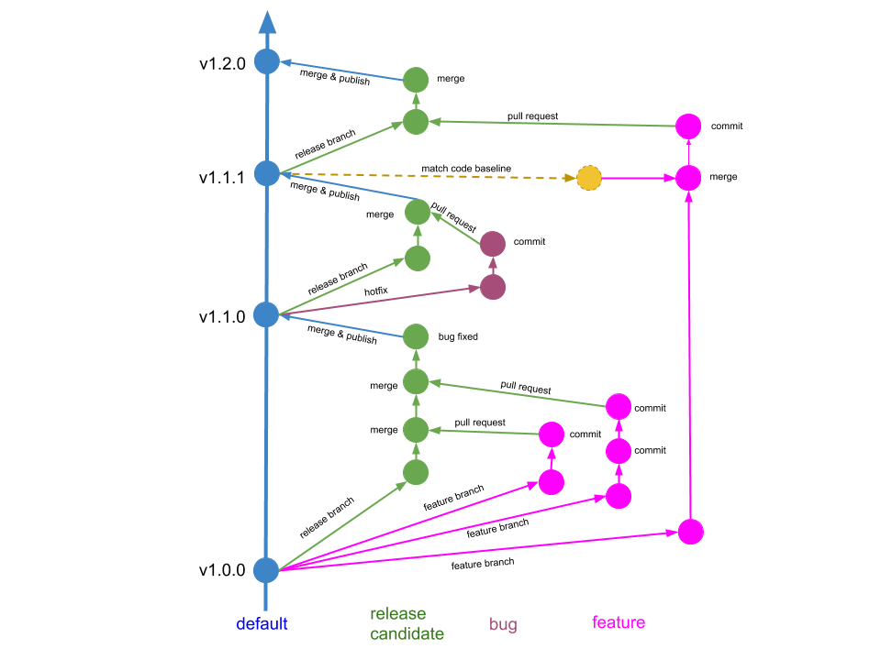

## Versioning

Given a version number MAJOR.MINOR.PATCH, increment the:

1. MAJOR version when you make incompatible API changes,
2. MINOR version when you add functionality in a backwards compatible manner, and
3. PATCH version when you make backwards compatible bug fixes.

Additional labels for pre-release and build metadata are available as extensions to the MAJOR.MINOR.PATCH format.

#### 

#### 

#### 

#### 

#### 

#### 

#### 

#### 

#### 

# C# (.NET) Coding Standards

#### **1. Use PascalCasing for class names and method names:**

public class ClientActivity

{

public void ClearStatistics()

{

//...

}

public void CalculateStatistics()

{

//...

}

}

*Why: consistent with the Microsoft's .NET Framework and easy to read.*

#### **2. Use camelCasing for method arguments and local variables:**

public class UserLog

{

public void Add(LogEvent logEvent)

{

int itemCount = logEvent.Items.Count;

// ...

}

}

*Why: consistent with the Microsoft's .NET Framework and easy to read.*

#### **3. Do not use Hungarian notation or any other type identification in identifiers**

// Correct

int counter;

string name;

// Avoid

int iCounter;

string strName;

*Why: consistent with the Microsoft's .NET Framework and Visual Studio IDE makes determining types very easy (via tooltips). In general you want to avoid type indicators in any identifier.*

#### **4. Do not use Screaming Caps for constants or readonly variables:**

// Correct

public const string ShippingType = "DropShip";

// Avoid

public const string SHIPPINGTYPE = "DropShip";

*Why: consistent with the Microsoft's .NET Framework. Caps grab too much attention.*

#### **5. Use meaningful names for variables. The following example uses seattleCustomers for customers who are located in Seattle:**

var seattleCustomers = from customer in customers

where customer.City == "Seattle"

select customer.Name;

*Why: consistent with the Microsoft's .NET Framework and easy to read.*

#### **6. Avoid using Abbreviations. Exceptions: abbreviations commonly used as names, such as Id, Xml, Ftp, Uri.**

// Correct

UserGroup userGroup;

Assignment employeeAssignment;

// Avoid

UserGroup usrGrp;

Assignment empAssignment;

// Exceptions

CustomerId customerId;

XmlDocument xmlDocument;

FtpHelper ftpHelper;

UriPart uriPart;

*Why: consistent with the Microsoft's .NET Framework and prevents inconsistent abbreviations.*

#### **7. Use PascalCasing for abbreviations 3 characters or more (2 chars are both uppercase):**

HtmlHelper htmlHelper;

FtpTransfer ftpTransfer;

UIControl uiControl;

*Why: consistent with the Microsoft's .NET Framework. Caps would grab visually too much attention.*

#### **8. Do not use Underscores in identifiers. Exception: you can prefix private fields with an underscore:**

// Correct

public DateTime clientAppointment;

public TimeSpan timeLeft;

// Avoid

public DateTime client_Appointment;

public TimeSpan time_Left;

// Exception (Class field)

private DateTime _registrationDate;

*Why: consistent with the Microsoft's .NET Framework and makes code more natural to read (without 'slur'). Also avoids underline stress (inability to see underline).*

#### **9. Use predefined type names (C# aliases) like int, float, string for local, parameter and member declarations. Use .NET Framework names like Int32, Single, String when accessing the type's static members like Int32.TryParse or String.Join.**

// Correct

string firstName;

int lastIndex;

bool isSaved;

string commaSeparatedNames = String.Join(", ", names);

int index = Int32.Parse(input);

// Avoid

String firstName;

Int32 lastIndex;

Boolean isSaved;

string commaSeparatedNames = string.Join(", ", names);

int index = int.Parse(input);

*Why: consistent with the Microsoft's .NET Framework and makes code more natural to read.*

#### **10. Use implicit type var for local variable declarations. Exception: primitive types (int, string, double, etc) use predefined names.**

var stream = File.Create(path);

var customers = new Dictionary();

// Exceptions

int index = 100;

string timeSheet;

bool isCompleted;

*Why: removes clutter, particularly with complex generic types. Type is easily detected with Visual Studio tooltips.*

#### **11. Do use noun or noun phrases to name a class.**

public class Employee

{

}

public class BusinessLocation

{

}

public class DocumentCollection

{

}

*Why: consistent with the Microsoft's .NET Framework and easy to remember.*

#### **12. Do prefix interfaces with the letter I. Interface names are noun (phrases) or adjectives.**

public interface IShape

{

}

public interface IShapeCollection

{

}

public interface IGroupable

{

}

*Why: consistent with the Microsoft's .NET Framework.*

#### **13. Name source files according to their main classes. Exception: file names with partial classes reflect their source or purpose, e.g. designer, generated, etc.**

// Located in Task.cs

public partial class Task

{

}

// Located in Task.generated.cs

public partial class Task

{

}

*Why: consistent with the Microsoft practices. Files are alphabetically sorted and partial classes remain adjacent.*

#### **14. Organize namespaces with a clearly defined structure:**

// Examples

namespace Company.Product.Module.SubModule

{

}

namespace Product.Module.Component

{

}

namespace Product.Layer.Module.Group

{

}

*Why: consistent with the Microsoft's .NET Framework. Maintains good organization of your code base.*

#### **15. Vertically align curly brackets:**

// Correct

class Program

{

static void Main(string[] args)

{

//...

}

}

*Why: Microsoft has a different standard, but developers have overwhelmingly preferred vertically aligned brackets.*

#### **16. Declare all member variables at the top of a class, with static variables at the very top.**

// Correct

public class Account

{

public static string BankName;

public static decimal Reserves;

public string Number { get; set; }

public DateTime DateOpened { get; set; }

public DateTime DateClosed { get; set; }

public decimal Balance { get; set; }

// Constructor

public Account()

{

// ...

}

}

*Why: generally accepted practice that prevents the need to hunt for variable declarations.*

#### **17. Use singular names for enums. Exception: bit field enums.**

// Correct

public enum Color

{

Red,

Green,

Blue,

Yellow,

Magenta,

Cyan

}

// Exception

[Flags]

public enum Dockings

{

None = 0,

Top = 1,

Right = 2,

Bottom = 4,

Left = 8

}

*Why: consistent with the Microsoft's .NET Framework and makes the code more natural to read. Plural flags because enum can hold multiple values (using bitwise 'OR').*

#### **18. Do not explicitly specify a type of an enum or values of enums (except bit fields):**

// Don't

public enum Direction : long

{

North = 1,

East = 2,

South = 3,

West = 4

}

// Correct

public enum Direction

{

North,

East,

South,

West

}

*Why: can create confusion when relying on actual types and values.*

#### **19. Do not use an "Enum" suffix in enum type names:**

// Don't

public enum CoinEnum

{

Penny,

Nickel,

Dime,

Quarter,

Dollar

}

// Correct

public enum Coin

{

Penny,

Nickel,

Dime,

Quarter,

Dollar

}

*Why: consistent with the Microsoft's .NET Framework and consistent with prior rule of no type indicators in identifiers.*

#### **20. Do not use "Flag" or "Flags" suffixes in enum type names:**

// Don't

[Flags]

public enum DockingsFlags

{

None = 0,

Top = 1,

Right = 2,

Bottom = 4,

Left = 8

}

// Correct

[Flags]

public enum Dockings

{

None = 0,

Top = 1,

Right = 2,

Bottom = 4,

Left = 8

}

*Why: consistent with the Microsoft's .NET Framework and consistent with prior rule of no type indicators in identifiers.*

#### **21. Use suffix EventArgs at creation of the new classes comprising the information on event:**

// Correct

public class BarcodeReadEventArgs : System.EventArgs

{

}

*Why: consistent with the Microsoft's .NET Framework and easy to read.*

#### **22. Name event handlers (delegates used as types of events) with the "EventHandler" suffix, as shown in the following example:**

public delegate void ReadBarcodeEventHandler(object sender, ReadBarcodeEventArgs e);

*Why: consistent with the Microsoft's .NET Framework and easy to read.*

#### **23. Do not create names of parameters in methods (or constructors) which differ only by the register:**

// Avoid

private void MyFunction(string name, string Name)

{

//...

}

*Why: consistent with the Microsoft's .NET Framework and easy to read, and also excludes possibility of occurrence of conflict situations.*

#### **24. Use two parameters named sender and e in event handlers. The sender parameter represents the object that raised the event. The sender parameter is typically of type object, even if it is possible to employ a more specific type.**

public void ReadBarcodeEventHandler(object sender, ReadBarcodeEventArgs e)

{

//...

}

*Why: consistent with the Microsoft's .NET Framework and consistent with prior rule of no type indicators in identifiers.*

#### **25. Do use suffix Exception at creation of the new classes comprising the information on exception:**

// Correct

public class BarcodeReadException : System.Exception

{

}

*Why: consistent with the Microsoft's .NET Framework and easy to read.*